
YEAR 11
General Human Biology: Task Three

Student name _________________________ Teacher ____________________________

TEST: RESPIRATORY SYSTEM Weighting: 4%
Working time for paper: 45 Minutes
Materials to be provided by the student:
Blue/Black Pen, pencil, eraser or correction fluid, and ruler
Marks available:
 | Number of questions available | Suggested working time (minutes) | Marks available | Student score
Part A: Multiple-choice | 5 | 5 | 5
Part B: Short answer | 6 | 25 | 22
Part C: Extended answer | 2 | 15 | 12
Totals | 13 | 45 | 39
Teacher Feedback:

Part A: Multiple Choice

- Which answer correctly lists the level of organisation from smallest to largest?
- Cell -> Organ -> Tissue -> Organ System
- Cell -> Tissue -> Organ -> Organ System
- Organ System -> Tissue -> Cell -> Organ

- Where does gas exchange take place in the respiratory system?
- Alveoli
- Bronchi
- Epiglottis
- Larynx

- What is the correct equation for aerobic respiration?
- Glucose + Oxygen -> Carbon Dioxide + Water + (Energy)
- Glucose + Carbon Dioxide + Oxygen -> Water + Energy
- Energy + Glucose -> Oxygen + Carbon Dioxide + Water
- Glucose + Carbon Dioxide -> Water + Energy + Oxygen

- Where in the cell does the majority of aerobic respiration take place?
- Cytoplasm
- Nucleus
- Mitochondria
- Chloroplast

- What is the difference between aerobic respiration and anaerobic respiration?
- Oxygen is not present in anaerobic respiration
- There is no difference
- Aerobic requires more inputs than anaerobic respiration
- Carbon dioxide is only present in anaerobic respiration

Part B: Short Answer

- Define the following: (2 marks)
  - Aerobic Respiration: ____________________________________________________________________________________________________________________________________________________________________________________________________________________________________________________________________________________
  - Anaerobic Respiration:
_________________________________________________________________________________________________________________________________________________________________________________________________________________________________________________________________________________________________________________________________________________________

- How is an oxygen debt created and how is it repaid? (2 marks)
_______________________________________________________________________________________________________________________________________________________________________________________________________________________________________________________________________________________________________________________________________________________________________________________

- Identify and describe the three rules of the cell theory? (3 marks)
__________________________________________________________________________________________________________________________________________________________________________________________________________________________________________________________________________________________________________________________________________________________________________________________________________________________________________________________________

- Describe the function of the cell membrane? (3 marks)
__________________________________________________________________________________________________________________________________________________________________________________________________________________________________________________________________________________________________________________________________________________________________________________________________________________________________________________________________

- Identify and describe the four features for efficient gas exchange. You may include a diagram to aid your response (6 marks)
________________________________________________________________________________________________________________________________________________________________________________________________________________________________________________________________________________________________________________________________________________________________________________________________________________________________________________________________________________________________________________________________________________________________________________________________________________________________________________________________________________

- With the aid of a diagram, explain how the diaphragm assists in breathing (6 marks)
____________________________________________________________________________________________________________________________________________________________________________________________________________________________________________________________________________________________________________________________________________________________________________________________________________________________________________________________________________________________________________

Part C: Extended Answer

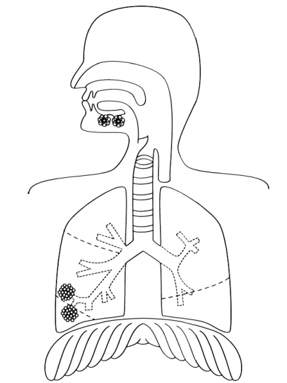
- Choose 6 parts of the respiratory system and clearly label them (6 marks)

- Describe the types of lung damage that can be caused by direct and indirect smoking. (6 marks)

____________________________________________________________________________________________________________________________________________________________________________________________________________________________________________________________________________________________________________________________________________________________________________________________________________________________________________________________________________________________________________________________________________________________________________________________________________________________________________________________________________________________________________________________________________________________________________________________________________________________________________________________________________________________________________________________________________________________________________________________________________________________________________________________________________________________________________________________________________________________________________________________________________________________________________________________________________________________________________________________________________________________________________________________________________________________________________________________________________________________________________________________________

